**CHAPTER 1**

**INTRODUCTION**

# 1.1 Introduction

The “CrypteX” has been deployed to override the problems prevailing In the practicing manual system. No formal knowledge is needed for the user to use this system. The cryptocurrency trading website is error-free, secure, reliable, and fast

# 1.2 PROJECT AIMS AND OBJECTIVES This project’s aims and objectives will be achieved after the completion of this project

.

* To protect and defend the interest of its members
* To provide safe and secure crypto trading website
* To provide convenience
* To provide the best facility
* To achieve the financial goal
* To provide daily buzz around the WEB3 world

# 1.3 BACKGROUND OF THE PROJECT

Key Features of the CrypteX

User-Friendly Trading Platform: CrypteX is a user beginner-friendly cryptocurrency exchange platform with high trading volume. The exchange has very smooth navigation features and is enabled with multilingual support. It seamlessly functions on all the app devices as well.

Advanced Trading tools: CrypteX offers advanced trading charts, powerful graphs, and various tools for spot trading to their users. It has also launched first-of-kind peer-to-peer transactions (P2P) which is the first-ever automated machine that auto-matches the buyer and seller instantly. Then, CrypteX transfers the escrowed USDT to the buyer’s secure wallet and thus the whole transaction takes place.

Transaction Speed: CrypteX boasts of a strong and robust blockchain infrastructure, which is scalable and able to handle millions of transactions in just a frame of time.

Security Features: The exchange follows a two-factor authentication (2FA), which further provides an extra layer of security to your account. It also has a wallet system with 100% secure database.

Trading and Investment Products: At present, the user can trade in more than 200 crypto coins and more than 250 cryptocurrency pairs. Some popular available coins include:

Bitcoin (BTC)

Ethereum (ETH)

Litecoin (LTC)

Cardano (ADA)

Solana (SOL)

USD Coin (USDC)

Polkadot (DOT)

Dogecoin (DOGE)

Polygon (MATIC)

Uniswap (UNI)

**And many more.**

**CHAPTER 2**

**CONCEPT DEFINITION AND SCOPE**

# 2.1 Concept Statement

The online cryptocurrency and trading website is very user-friendly in that users can easily understand their registration and some services. There are so many types of packages like adventure and tour. There are client reviews available on our website you can check that. We always recommend to you the top recommendation of the WEB3 world. The registration page is there. In that users can register and easily start trading by depositing their money in wallet.

The website provides some services that are live trading charts and can easily deposit money in a wallet for buying and selling crypto these services are provided, also provide crypto-related news and blog. It can guide you and tell the information about the trading of crypto and NFT.

Modules:

* OUR SERVICES - it provides so many facilities like news and blog, portfolio management, Crypto trading, NFT trading, and withdrawal and deposit of money from the wallet.
* WHY TO CHOOSE US- we provide affordable service and minimal brokerage services and easy withdrawal and deposition of money.

**CHAPTER 3**

**IMPLEMENTATION**

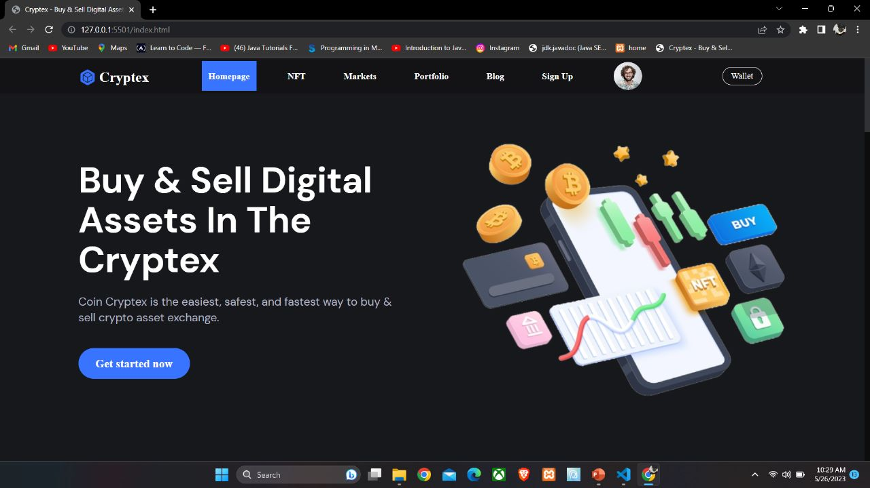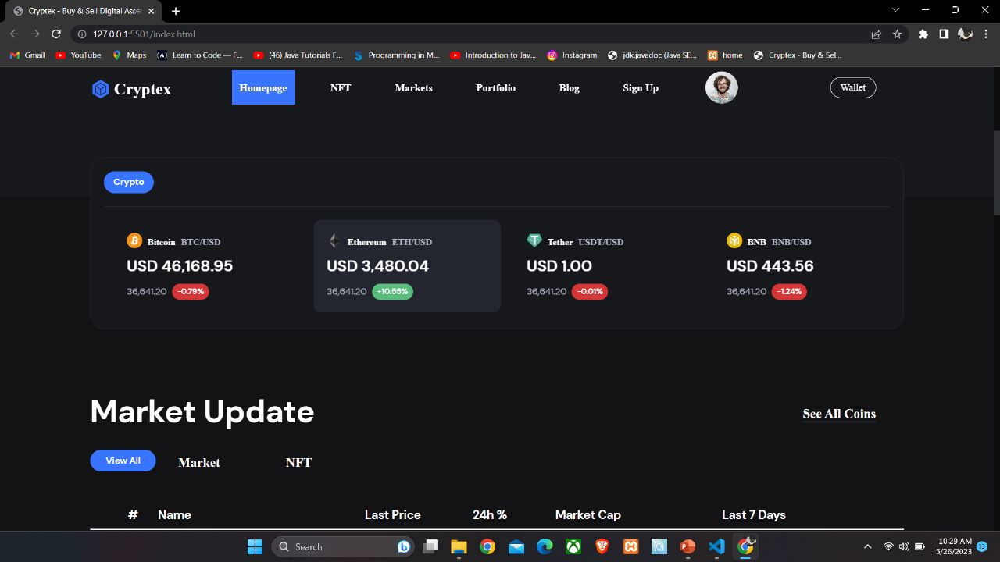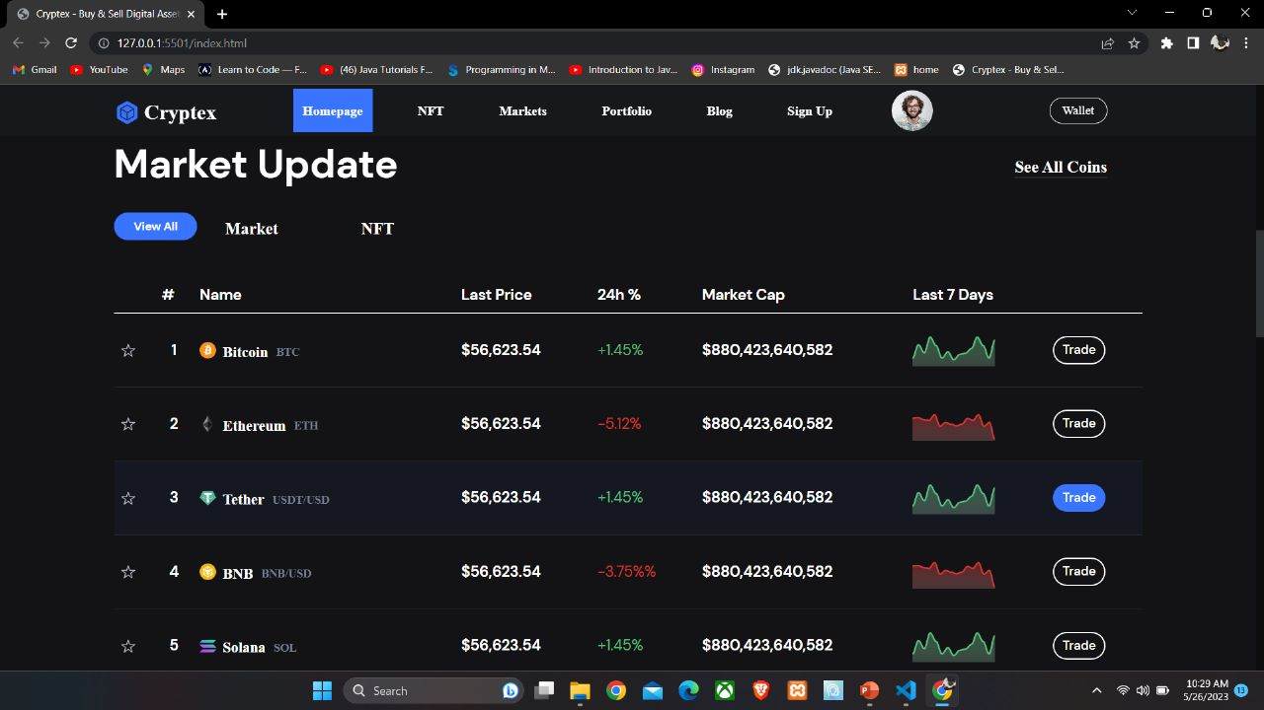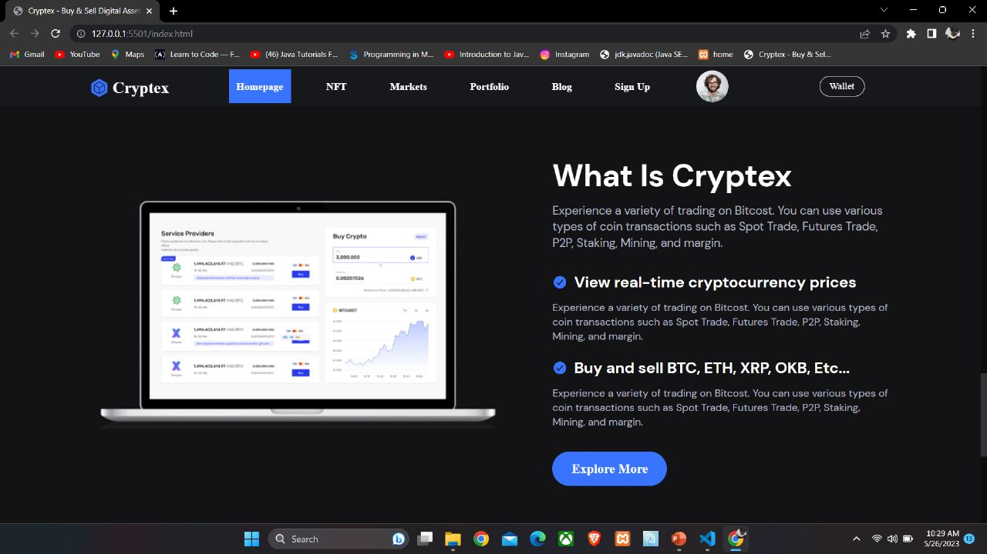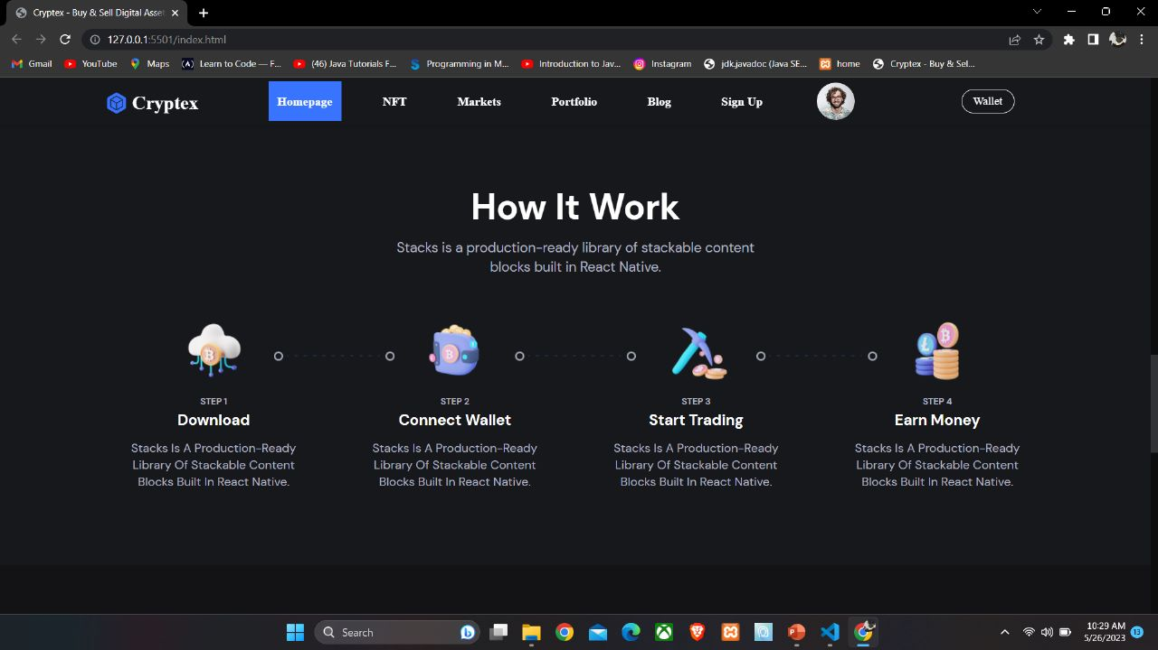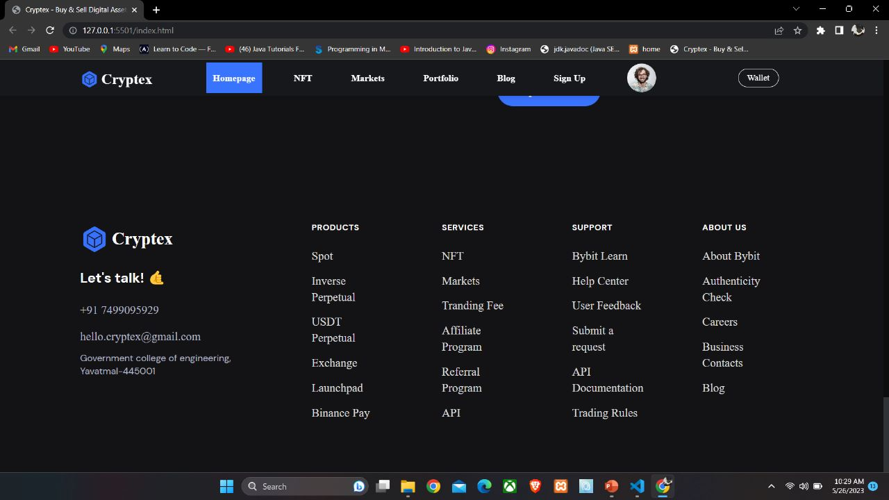

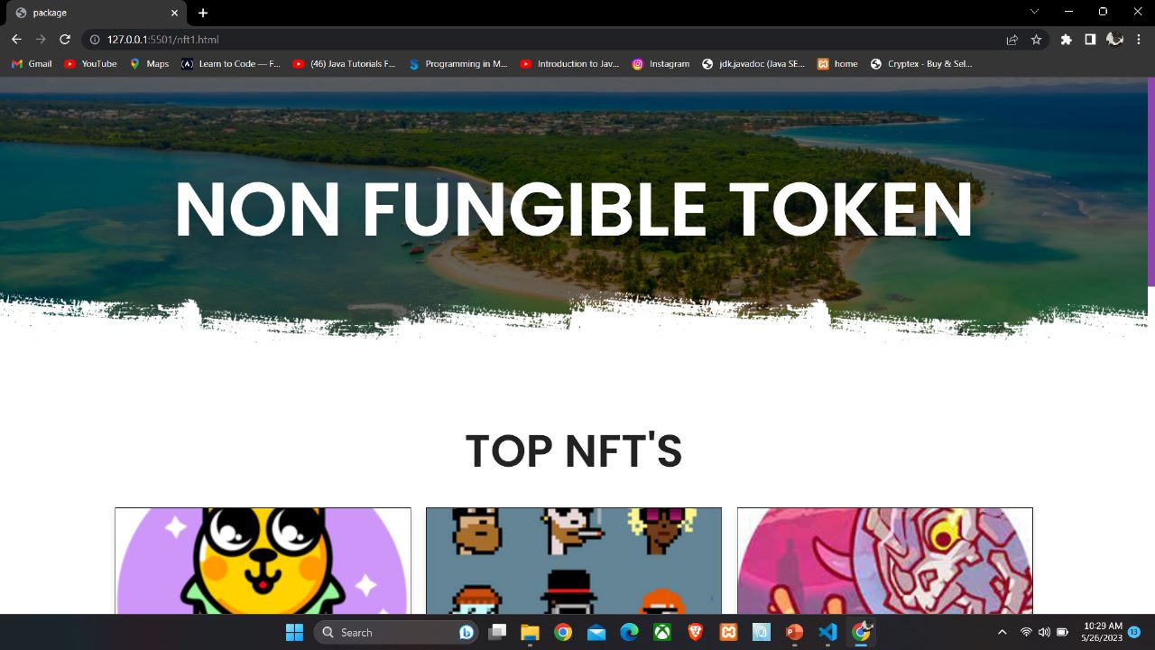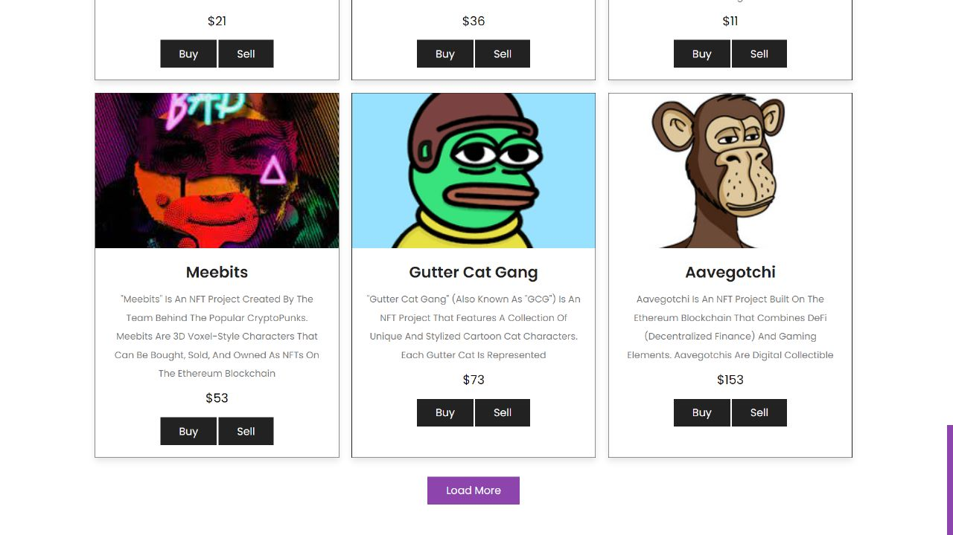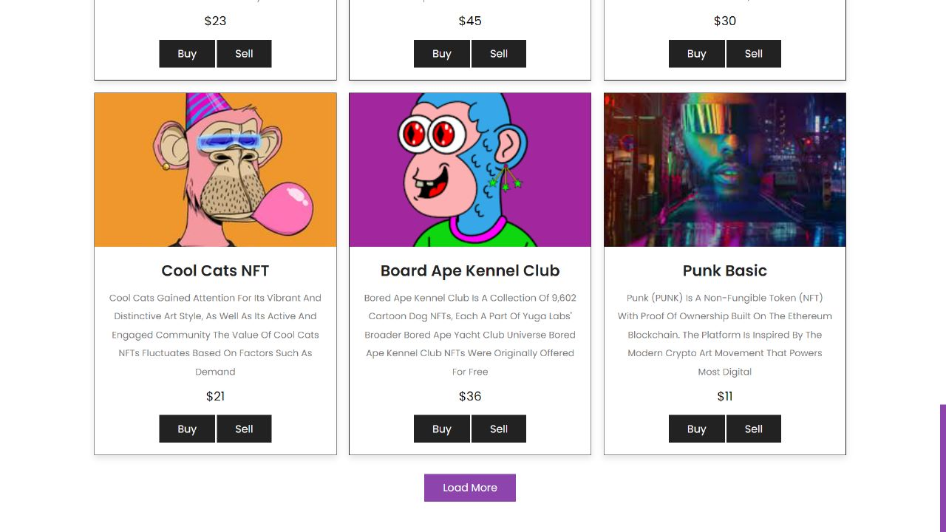

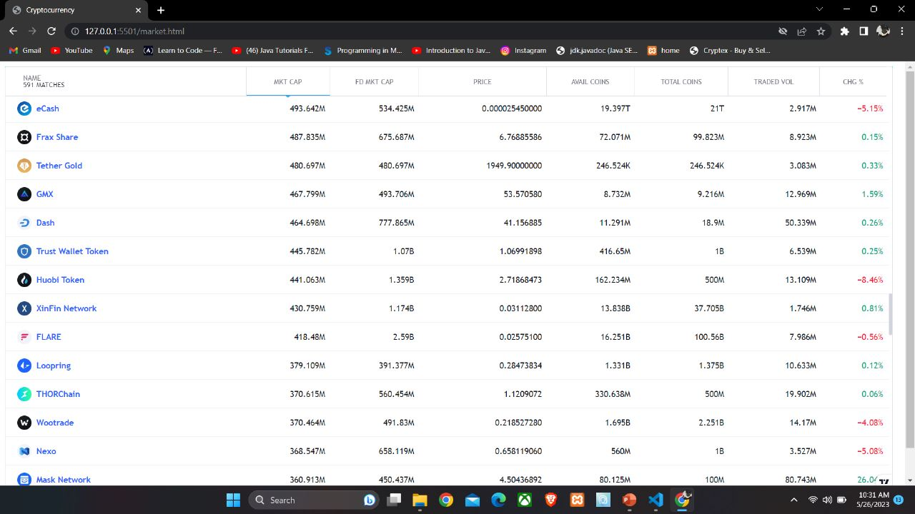

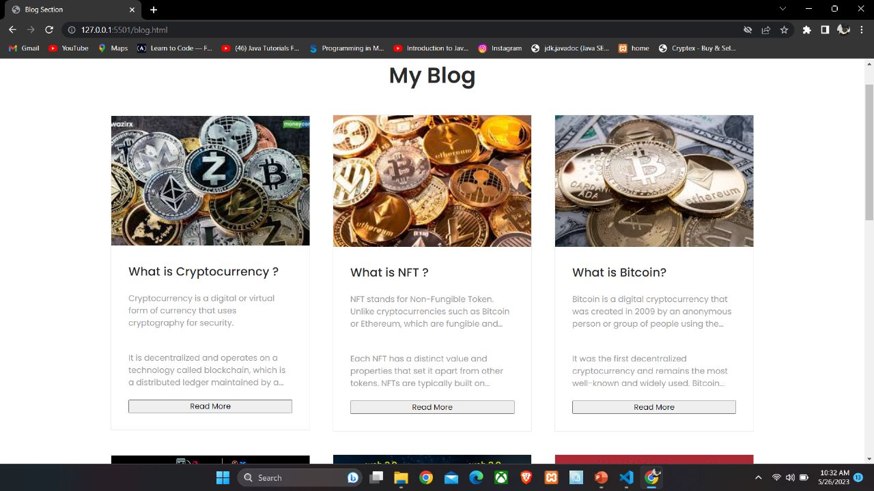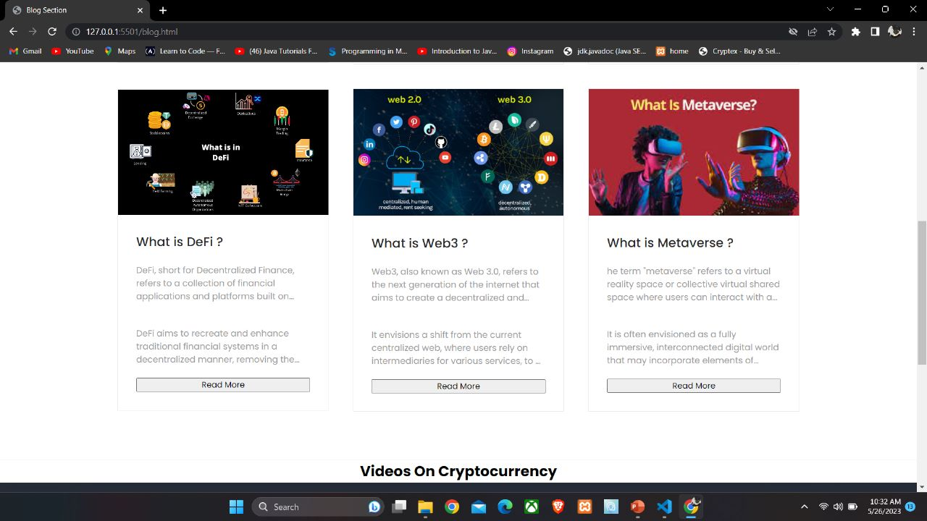

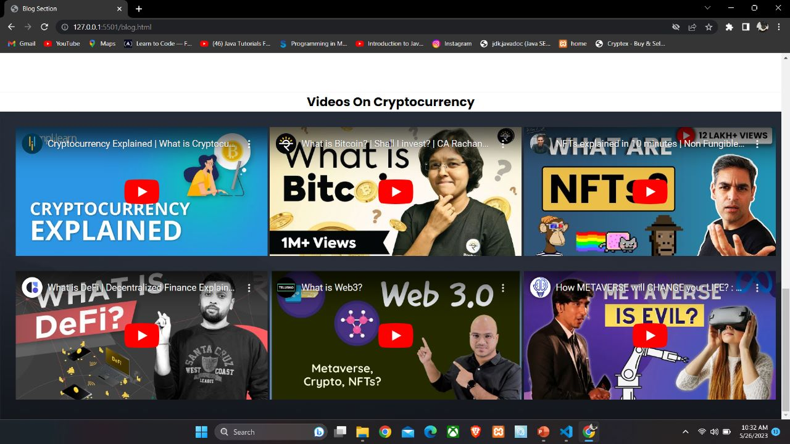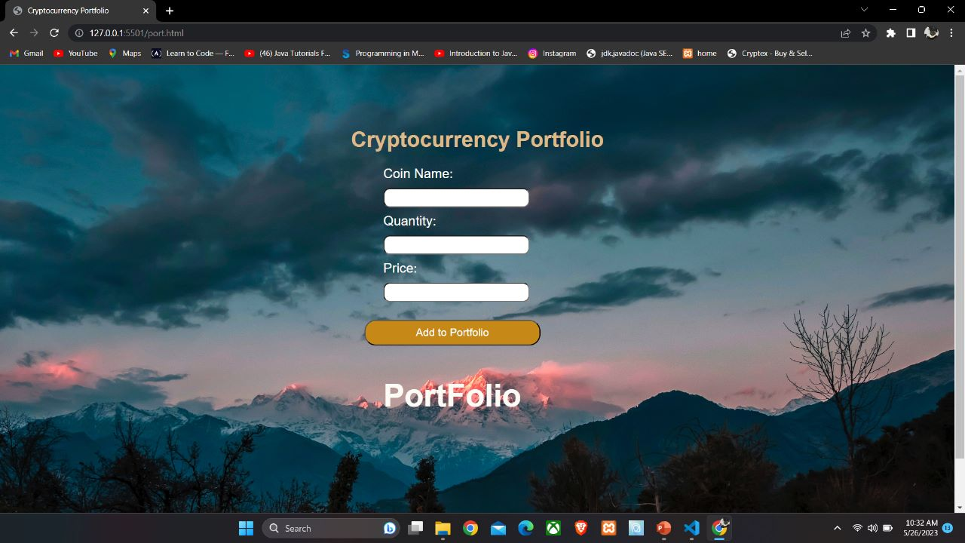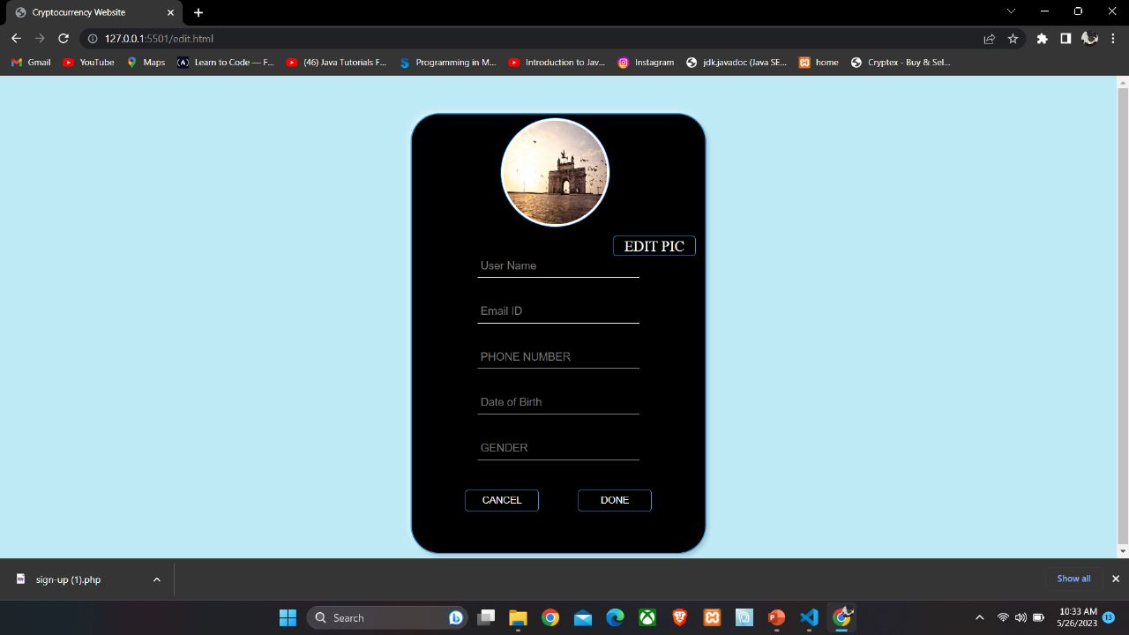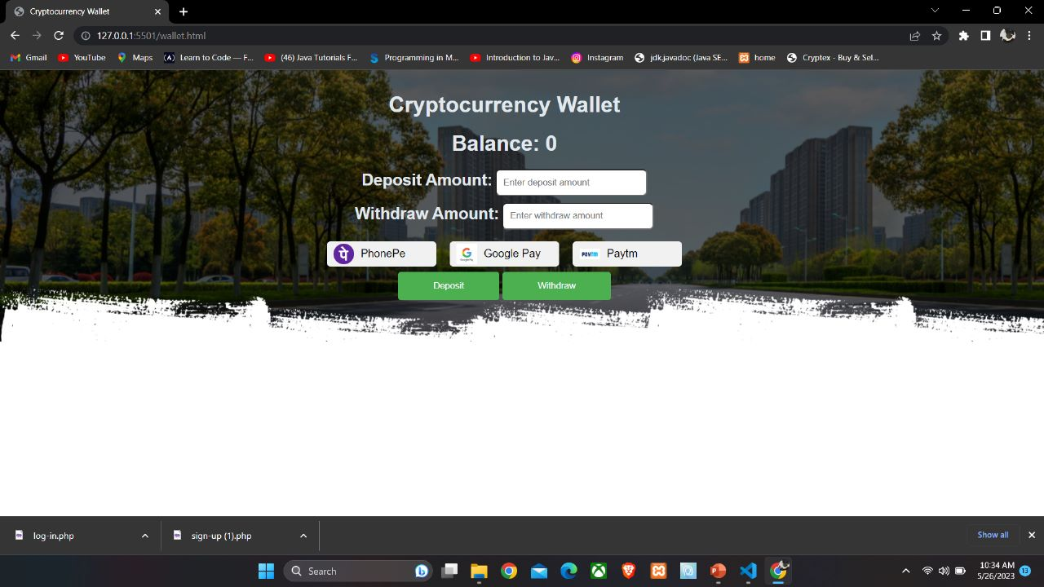

**CHAPTER 4**

# ADVANTAGES

* Live crypto chart and NFT deals
* Provide guide and news
* Provide so many facilities like withdrawal and deposit
* Seamless trading experience
* Reviews are available

# DISADVANTAGES

* Customer services issues
* Cancellation of orders is not available
* Statement of portfolio is not available
* Prebooking of trade is not available

**CHAPTER 5**

**CONCLUSION AND FUTURE SCOPE**

# Conclusion

Our project is only to satisfy the needs of traders and manage their services. It is easy to handle the website anyone can easily understand the functions Anyone can easily book their tickets and register after filing their details.

Also, CrypteX offers advanced trading charts, powerful graphs, and various tools for spot trading to their users. It has also launched first-of-kind peer-to-peer transactions (P2P) which is the first-ever automated machine that auto-matches the buyer and seller instantly. Then, CrypteX transfers the escrowed USDT to the buyer’s secure wallet and thus the whole transaction takes place. Terms and conditions are given read them carefully.

# Future Scope

* We can add services regarding profit and loss statements on the portfolio
* We can give more advanced facilities like trade mining
* We can add more features of tax on trading statements.
* Provide goal-oriented guidance regarding your future goal
* And to solve the above disadvantages

**REFERENCES**

* [**https://www.w3schools.com/**](https://www.w3schools.com/)
* <https://www.w3schools.com/php/>
* <https://www.javatpoint.com/>
* [**https://www.youtube.com/**](https://www.youtube.com/)
* [**https://www.youtube.com/results?search_query=code+ with+harry+**](https://www.youtube.com/results?search_query=code+with+harry)
* https://developer.mozilla.org/